SYNOPSIS ON

**WEBSITE ON ONLINE MOBILE SHOPPING**

Submitted by:-

**DEEPAK BHARDWAJ**

Enroll. No. 00726518118

B.VOC (SD)

Under the guidance of

And

Submitted to:-

Ms. Swati Rehal



GURU NANAK DEV INSTITUTE OF TECHNOLOGY

**Affiliated to**

**Guru Gobind Singh Indraprastha University**

TABLE OF CONTENT

1. INTRODUCTION

2. OBJECTIVE OF THE PROJECT

3. SCOPE OF THE PROJECT

4. ENHANCEMENT

5. FLOW CHART

6. REQUIREMENTS SOFTWARE & HARDWARE

7. CONCLUSION

8. REFERENCES

1.Introduction

This project is aimed at developing a Web application that depicts online Shopping of mobiles and purchasing using Payment Gateway. Using this software, companies can improve the efficiency of their services .Online Shopping is one of the applications to improve the marketing of the company’s products. This web application involves all the features of the online shopping.

2. Objective of the project

This software helps customer to find different mobiles, their features, and new updates easily. It is designed such a way that one can view all the updates of the mobile from any place through online. The software will help in easy maintaining and updating products in the website for the administrator. Also quick and easy comparison of different products for the customers.

3. Scope of the project

This system will reduce the manual operation required to maintain all the records of booking information. And also generates the various reports for analysis. Main concept of the project is to enter transaction reports and to maintain customer records. Hence this software can be used in any mobile showroom to maintain their record easily.

4. further enhancement

This web application involves almost all the features of the online shopping. The future implementation will be online help for the customers and chatting with website administrator.

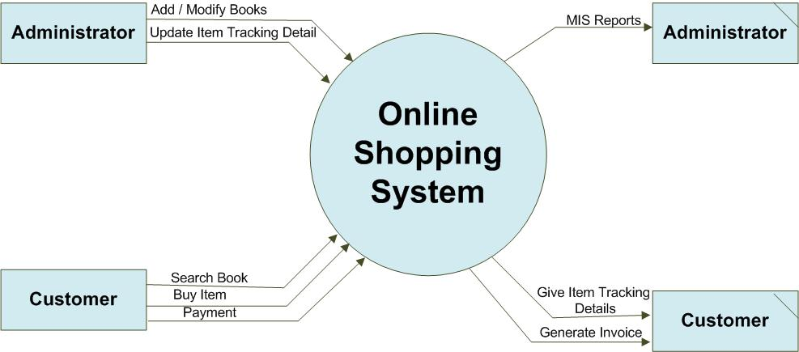

**Data Flow Diagram of the Shopping Site**

6.1Software Requirements:

**Languages used:**

**Front End:**

• Notepad + +

• HTML

• CSS

• PHP

•  ASP.NET

**Back End:**

• Microsoft SQL Server 2008

6.2Hardware Requirements:

• Processor: Pentium 4 or above

• RAM :1 GB or above

• Hard disk :40 GB or above

7.Conclusion

The project entitled “Online Mobile Shopping” is developed using ASP.Net as front end and SQL Server database in back end to computerize the process of online buying and selling of mobiles in a showroom. This project covers only the basic features required.

8.REFERENCES

1.<https://www.youtube.com/watch?v=v1otHJGlV5g&list=PLuIr1FMHB3x3HRtWm_-bUOJ2I6tRnPS06>

2. <https://www.youtube.com/watch?v=GvUTqsAm9vE&list=PLamqHyWseJOIliSZ23WDS1Ky-uU5yrjOk>

3.https://www.youtube.com/watch?v=5sxtZ10Vf3s&list=PLbGui_ZYuhihSr4HroBBQt_quHL42JLif

4.https://www.youtube.com/watch?v=3qti7Vof_7Q&list=PLbGui_ZYuhiiaQjuOfvgx_-gzVBlCxrk0